**Software architectural design**

**Model: SmartSONO MS-09**

**Document No. : Q5-29-028(03) Rev.4**

This document valid from the date of approval

|  |  |  |  |  |
| --- | --- | --- | --- | --- |
|  | Title | Name | Date | Signature |
| Prepared by | Researcher | H.W Jung | 2015.05.28 |  |
| Reviewed by | Director | J.H. Oh | 2015.05.28 |  |
| Approved by | CTO | G.Y. Kim | 2015.05.28 |  |

|  |
| --- |
| **META BIOMED CO., LTD.** |

**Revision History**

|  |  |  |  |
| --- | --- | --- | --- |
| Date | Revision | Description | Author |
| 2014.10.30 | 0 | 문서 초기 작업 | 정현우 |
| 2015.02.05 | 1 | SRS의 변경으로 인하여 디자인 수정 | 정현우 |
| 2015.03.05 | 2 | SRS의 변경으로 인하여 디자인 수정 | 정현우 |
| 2015.50.15 | 3 | SRS의 변경으로 인하여 디자인 수정 | 정현우 |
| 2015.05.28 | 4 | SRS의 변경으로 인하여 디자인 수정 | 정현우 |

1 Software Diagram and Description 4

1.1 Main Module 5

1.1.1 Database Module 6

1.1.2 Scan process Module 7

1.1.3 Scan operation flow (After RF Data Acquisition) 8

1.1.4 Pre-amp operation flow 10

1.2 Firmware Module 11

1.2.1 Tx flow (PW, Pulse Wave) 12

1.2.2 Tx flow (CW, Continue Wave) 13

1.2.3 Rx 14

# Software Diagram and Description

The software architecture consists of 5 modules and each module functions independently. Main Module combines it into a software unit.

Scan HW

Scan Process module

Main UI module

Database

Firmware module

Sequence module

## Main Module

Main UI module initializes hardware and software components in program initial run time and provides user interface to switch four operation areas. And also it has functions to set system options and display the current time and states of disk.



### Database Module

Database manages information, such as patients, scan studies, images and protocol information. The image data is stored in separate image file and is connected by DB information.

🡪 Flow chart



### Scan process Module

Scan process module works for scanning by sending several commands related for scan to Ultrasound hardware and makes images by post-processing result data of scan. This module also searches tuning value of hardware by pre-scanning.

🡪 Flow chart



### Scan operation flow (After RF Data Acquisition)

System software operates by scan procedure so as to correspond on clinical procedure. Switching to scan task area is done automatically after registration of patient. User creates study to prepare scan plan, and set scan parameter and scan plane to the study. After preparation of scan plan is completed, it is scanned by load/start scan command. To resume scanning additionally, creation of study, preparation of scan plan and load/start scan are repeated. When all of scan is finished, it is switched to patient registration task area by selecting end scan.

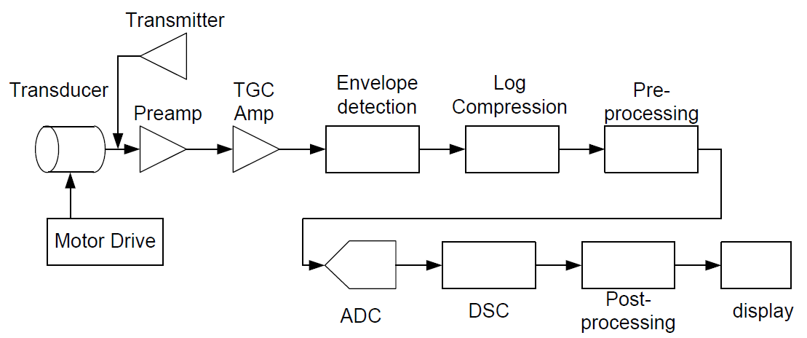



### Pre-amp operation flow

By option all procedure of pre-scan or a part of pre- can be executed. In the general scan procedure, pre-scan is executed at first when pre-scan is ON and main-scan is executed using the searched values there again. At pre-scan step, received data week RF. Therefore, this progress is important.



## Firmware Module

Firmware module is executed in DSP HW and works for RF signals and acquiring Ultrasound signals from patient

Firmware is executed by the following procedure.

1. After firmware data is downloaded from CCS to each DSP and DSP is booted, check if booting states is normal.
2. CCS downloads parameters for scan at DSP.
3. If CCS commands SCANREADY, firmware creates data structures for scan and prepares the scan start.
4. If CCS commands STARTSCAN, firmware starts scan by pre-set procedure by each DSP respectively.

### Tx flow (PW, Pulse Wave)



### Tx flow (CW, Continue Wave)



### Rx

